12/5/2017

**2018 herring forecast for Togiak**

Forecasted biomass, age composition, and weight at age

The recommended 2018 forecast for Togiak is 136,756 tons (Figures 1–3). The forecast age composition of the mature population (escapement plus harvest) exhibits more older fish both in number of fish (16% age-8, 16% age-9, and 18% age-12+; Figure 4) and in mature biomass (21,929 tons age-8, 22,868 tons age-9, and 31,274 tons age-12+, Figures 5 and 6). The model estimated proportion of age-12+ fish in both the mature population and in the commercial purse seine harvest was considerably higher than what was observed (Figures 7 and 8), so the forecast of 12+ fish is somewhat uncertain. The mature biomass forecast is a 10% decrease from the model hindcast of 2017 mature biomass (153,150 tons), nearly no change from the model estimate of 2017 spawning (escapement) biomass (136,021 tons), and a 5% increase from the 2017 forecast (130,852 tons).

The average weight of a fish in the forecasted mature population is 378g (Figure 6) and the average weight of a fish in the forecasted mature population that is vulnerable to the purse seine fishery is 381g. The difference between these two weights is due to the selectivity of the purse seine fleet, where selectivity includes gear/mesh selectivity, selectivity by fishers for particular schools at a given time, and the selectivity that occurs in time due to the fishery occurring early in the spawning run.

Survival, maturity, selectivity, and age-4 recruitment parameter estimates

The survival estimated by the model is 76% for ages 4–8 and only decreases 1% per age class for ages 9–12+ (Figure 9).

Estimated maturity ranges from 17% to 68% for ages 4–7 from 1980 to 1992 when post-fishery test fishing for age, sex, and length (ASL) was conducted regularly, and ranges from 9% to 70% for ages 4–7 from 1993 to 2017 when post-fishery test fishing for ASL occurred rarely. Maturity for ages 8–12+ was set at 100% for all years (Figure 10). The difference in maturity for young herring between these two periods is likely influenced by sampling only earlier in the spawning event in the 1993–2017 period since young fish have been observed to return late. Due to difficulty sampling the complete spawning event in both time periods, it is likely that the percent of young fish observed in samples and the respective maturity estimates for young fish are lower than that of the true mature population. Sensitivity analyses with a variety of estimated and fixed maturity schedules suggest that using the estimated maturity from the later time period for forecasting 2018 biomass has a relatively small impact on the forecasted biomass, when using a moderate forecast of recruitment for 2018.

Seine selectivity ranges from 8% to 88% for ages 4–8 from 1980 to 2001, and ranges from 7% to 93% from 2002 to 2017. Selectivity for ages 9–12+ was set equal to 100% for all years (Figure 11). Selectivity was estimated separately for these two time periods due to decreases in the number of buyers, daily processing capacity, and purse seine and gillnet effort in the later time period (see Salomone et al. 2017, “2016 Bristol Bay Area Annual Management Report”, Appendix B1).

Togiak recruitment of age-4 fish was the greatest in 1981 and 1982, with lower peaks in 1991, 2001, and 2009 (Figure 12). Recruitment in 2017 was estimated to be higher than recruitment in 2014–2016, but not as large as the previous four peaks. Since the cohort of recruit fish in 2017 has only been observed once, the estimate of recruitment likely contains considerable uncertainty and will improve as the cohort is observed again in future years.

Model fit

The model estimated mature biomass follows the biomass estimated by aerial surveys that were included in the model well (Figure 1), fitting above some and below others depending on other aerial survey estimates and the age composition datasets. The largest difference between the model trend and the aerial survey estimates occurred during 1984–1991 when there were no aerial survey estimates included in the model and when the age compositions showed an extremely large two-year recruitment event moving through the population after the 1977 regime shift (Figure 1). The difference between the 2018-forecast model fit and previous years’ model fits is primarily due to the different interannual weighting of aerial survey estimates and revised weighting of aerial surveys and age compositions in the objective function (Figure 2). In previous years, all aerial surveys included in the model were weighted equally, whereas this year they were given different weights. In previous years the inter-dataset weighting was: aerial surveys at 1.0, total run age composition at 0.5, and purse seine age composition at 0.25. For the 2018 forecast, the datasets were weighted according to the confidence staff has in their accuracy: aerial surveys at 0.25, total run age composition at 0.5, and purse seine age composition at 1.0. The decrease in the model trend since the highly weighted 2015 aerial survey is due to the moderately low recruitment in the last few years. The 2016 and 2017 surveys were not included in the model because they were expected to be biased low due to very low survey frequency and particularly early run timing in 2016 and due to weather in 2017.

Model-estimated age compositions for both the mature population (Figure 7) and the commercial seine fishery (Figure 8) fit very well in most years for most age classes. One notable lack of fit in 2017 is for the 12+ age group. Examining the patterns of age compositions over the years, the 12+ age class generally increases after a year with good sized age-11 age classes (see 1989–1990, 1998–2000, and 2008–2009). However, while the model indicates that the 12+ class should be good sized in 2017 following the age-4 cohort in 2009 that appeared strong in 2010–2014 samples, age composition survey samples in 2017 do not match model projections (could be either sampling error in 2017, or some process such as increased mortality of older age classes during the recent couple of years that is not represented in the model).

Final Model Description

*Similar* to the 2016-forecast ASA model, the recommended 2018-forecast ASA model

1. uses the same datasets and population dynamics equations,
2. uses a least squares estimator in the objective function,
3. estimates age-specific survival (a single value for ages 4–8 and an estimated linear decrease in survival for ages 9–12+) that is constant over years (Figure 9),
4. uses the most recent survival and maturity for the 2018 forecast, and
5. has two maturity schedules (one for 1980–1992 when post-fishery sampling for ASL occurred frequently and one for 1993–2017 when post-fishery sampling for ASL was rare) and each maturity schedule has an increasing percent of mature fish up through age-7 and is fixed at 100% for ages 8–12+ (Figure 10).

*Unlike* to the 2016-forecast ASA model, the recommended 2018-forecast ASA model

1. was implemented in AD Model Builder instead of Excel,
2. is based on data starting from year 1980 (first year fish were aged past age 12, rather than 9+) instead of 1978,
3. used variable weighting of highly ranked surveys, rather than weighting them equally (Figure 1),
4. has two gear selectivity schedules to represent the difference in the number of buyers, daily processing capacity, and purse seine and gillnet effort between time periods and each selectivity schedule has an increasing percent of selected fish over ages (Figure 11),
5. used forecast weights at age that were based on the most recent two-year average weights at age from the purse seine fishery, which for this forecast were from 2015 and 2017 (Figure 13),
6. used between dataset weights of 0.25, 0.5, and 1.0 for the aerial biomass, total run age composition, and purse seine age composition log likelihood components, respectively, rather than 1.0, 0.5, and 0.25 as used for previous forecasts, and
7. used a forecast of mature age-4 fish (Figure 4) that was based on a ten year median of past age-4 recruitment (2006–2015) multiplied by the maturity of age-4 fish in the latest time period (9% mature for 1993–2017). The recruitment in 2016 and 2017 were not included in the median because those recruitment estimates have a large amount of associated uncertainty (cohorts have only been seen twice or once, respectively, and the percentage of those cohorts that are mature and observed on the spawning grounds are very low).

Extra Figures

If there are additional figures you would like to see, or changes to the current figures (layout, color, bars versus points/lines), please let me know.

I look forward to hearing your thoughts,

Sherri

**Figures**

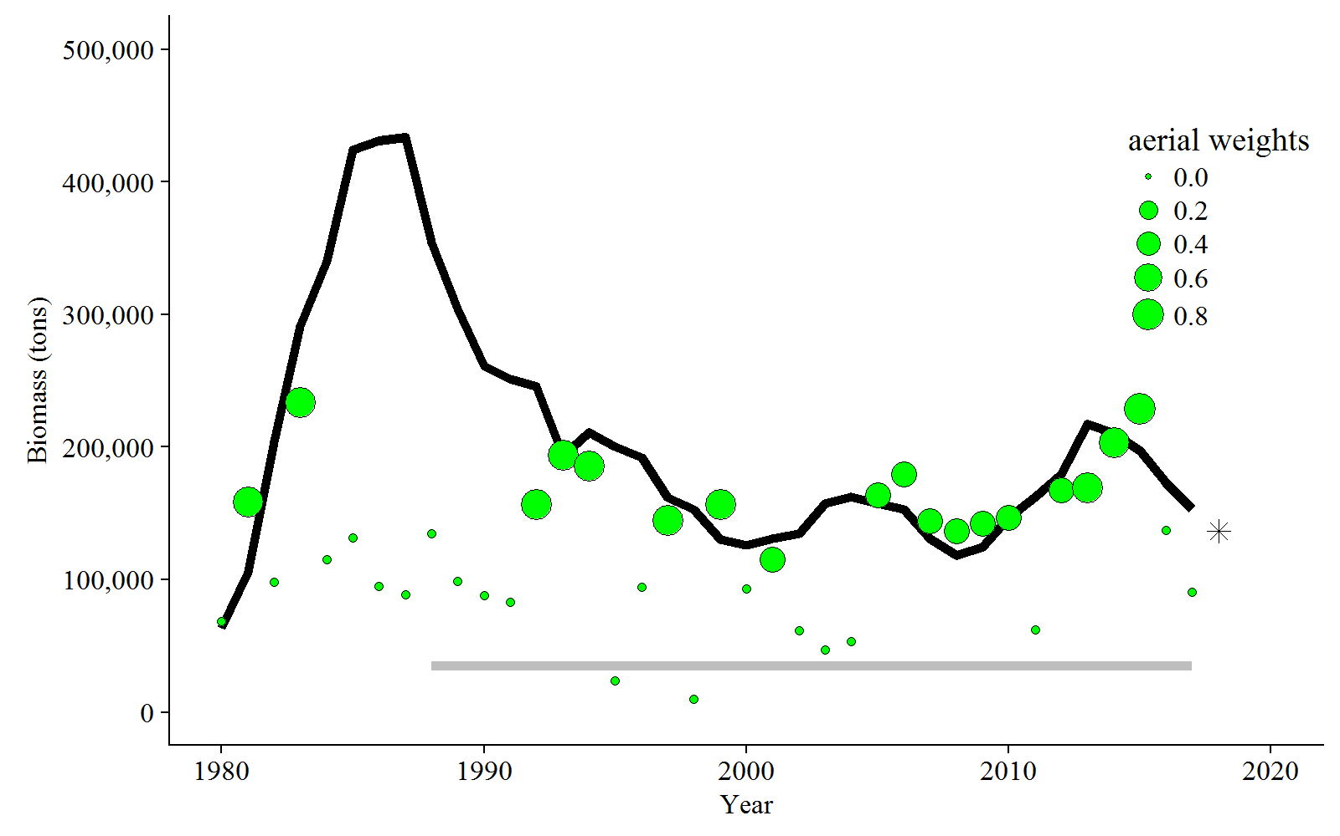

**Figure 1:** Aerial survey-estimated biomass plus pre-peak catch that were included in the model (green points), model-estimated mature biomass (black solid line), and model-estimated mature biomass forecast (black star). The size of the green points reflect the confidence weighting of each aerial survey estimate in the model based on weather, number of surveys, quality of surveys, and timing of surveys relative to the spawn (ranging from 0=no confidence to 1=perfect confidence). The grey line denotes the threshold.

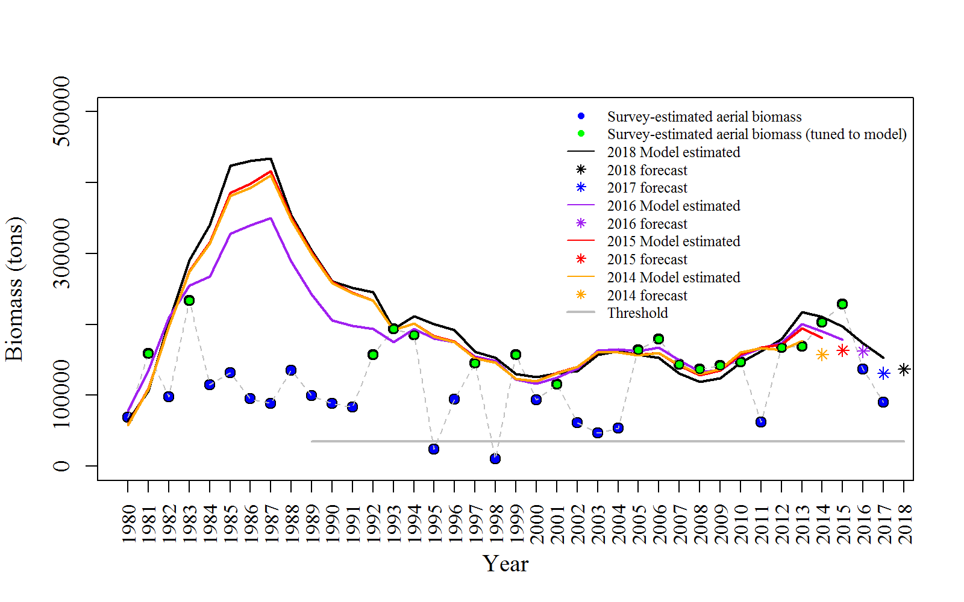

**Figure 2:** Comparison of past and current survey-estimated mature biomass (aerial survey-estimated biomass plus pre-peak catch; green points with black dashed line), model-estimated mature biomass (solid lines), and model-estimated mature biomass forecasts (stars).

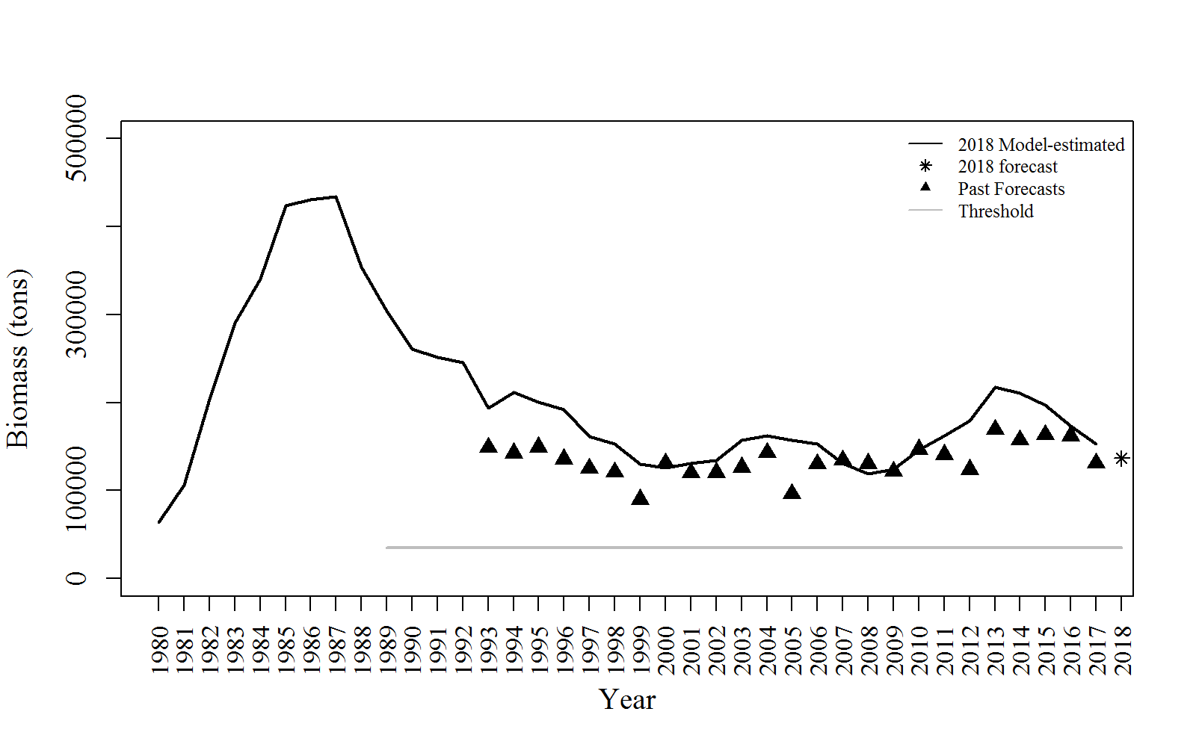**Figure 3:** Comparison of model-estimated mature biomass, 2018 forecast, and past forecasts to show past forecast performance.

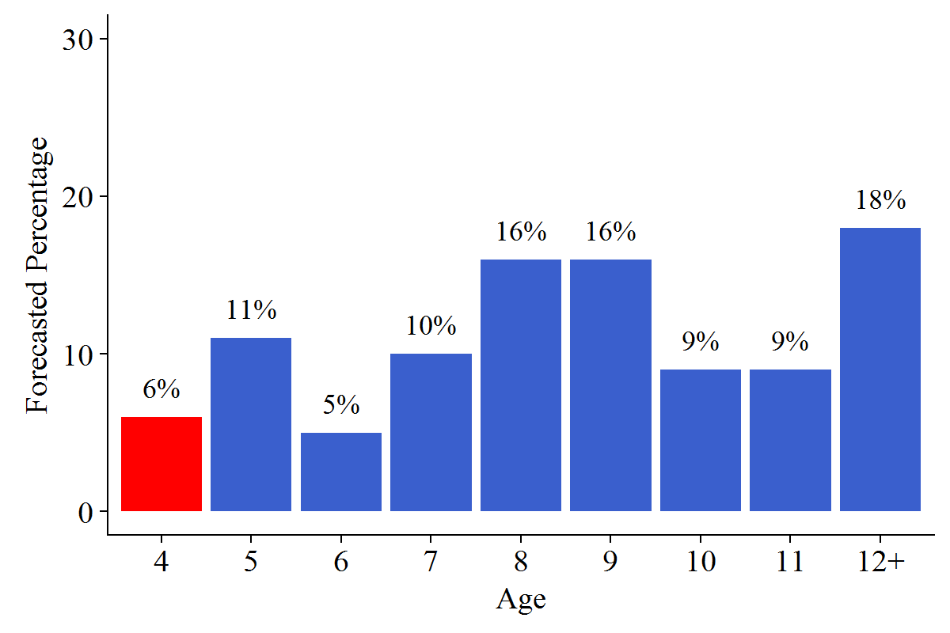

**Figure 4:** Forecasted percentage of mature numbers at age for forecast year. The percent of age-4 fish (red bar) was estimated with a 10-yr (2006–2015) median of past recruitments.

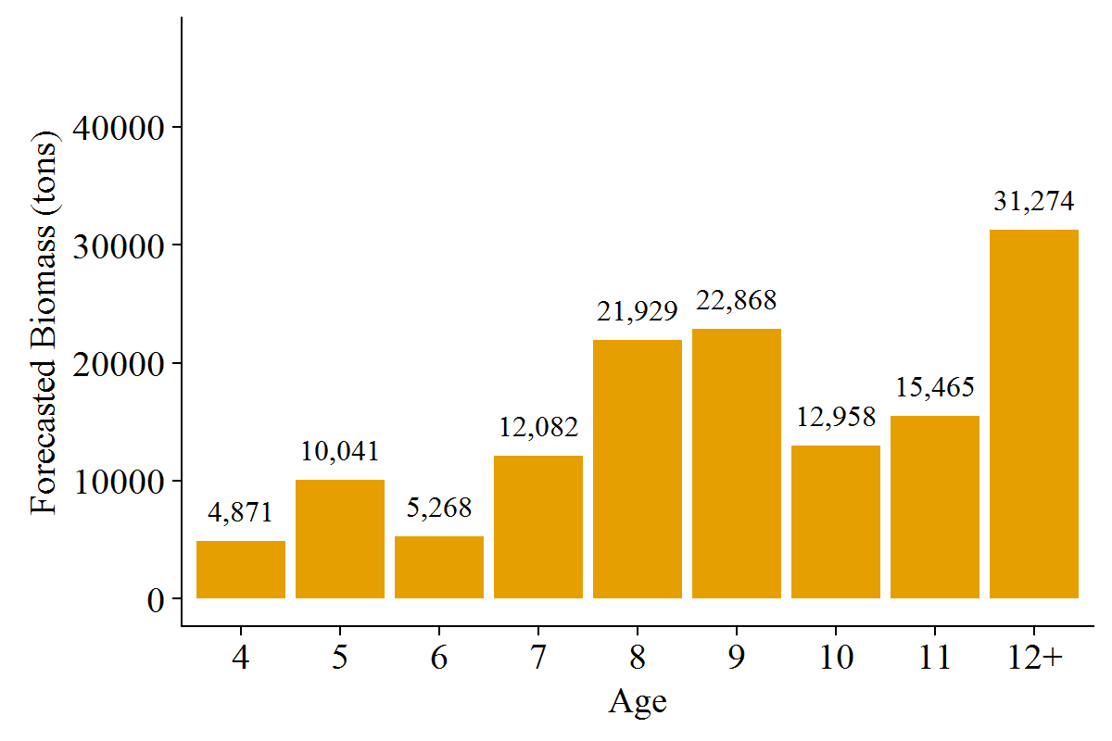

**Figure 5:** Forecasted mature biomass at age (tons) for forecast year.

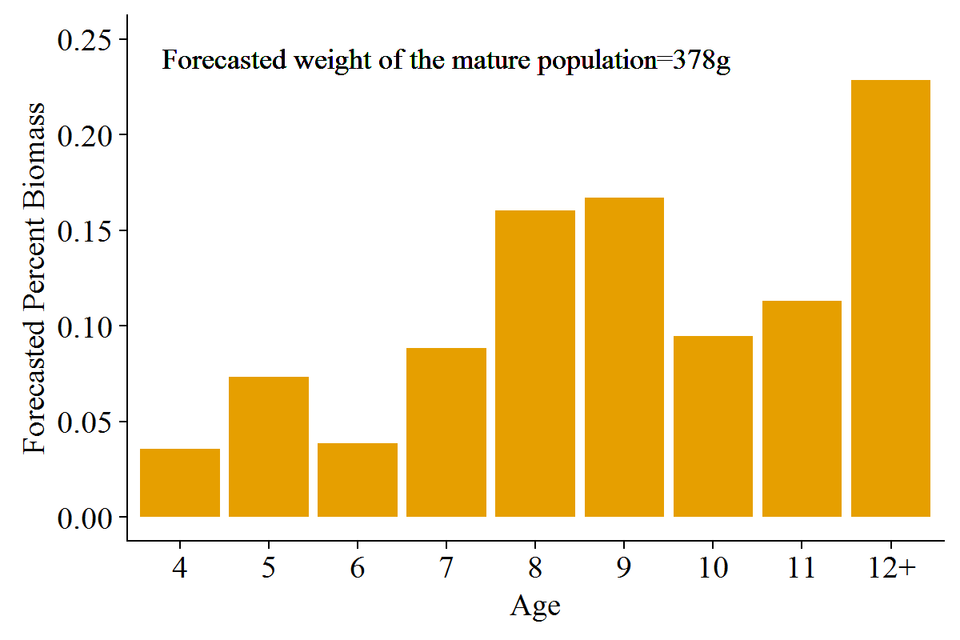

**Figure 6:** Forecasted percent mature biomass at age (tons) for forecast year with the forecasted weight of the mature population.

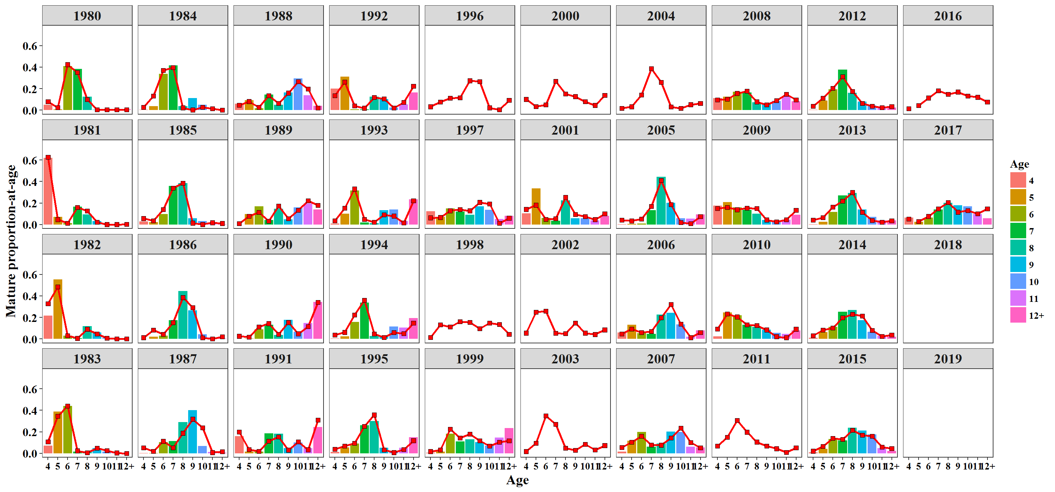

**Figure 7:** Comparison of observed (bars) and model-estimated (red line with square points) mature age compositions. Observed samples used to estimate age composition of the mature population biomass were from the commercial purse seine harvests on days of the peak run survey and the post-fishery survey, as well as from harvest prior to the peak.

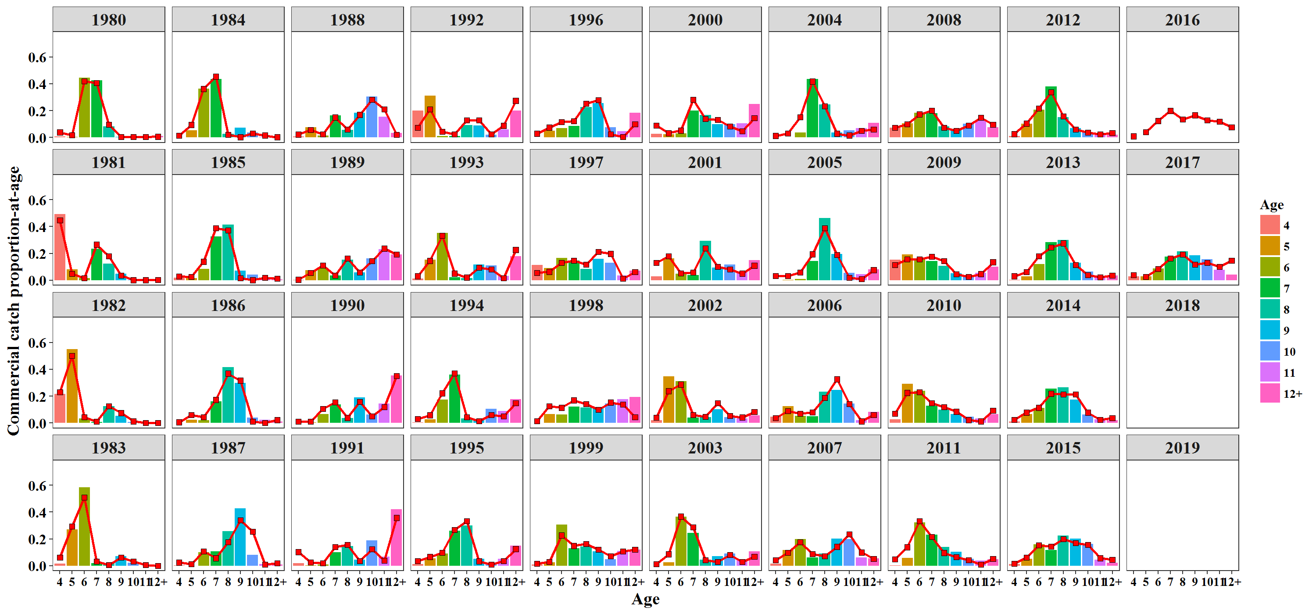

**Figure 8:** Observed (bars) and model-estimated (red line with square points) purse seine catch-age composition.

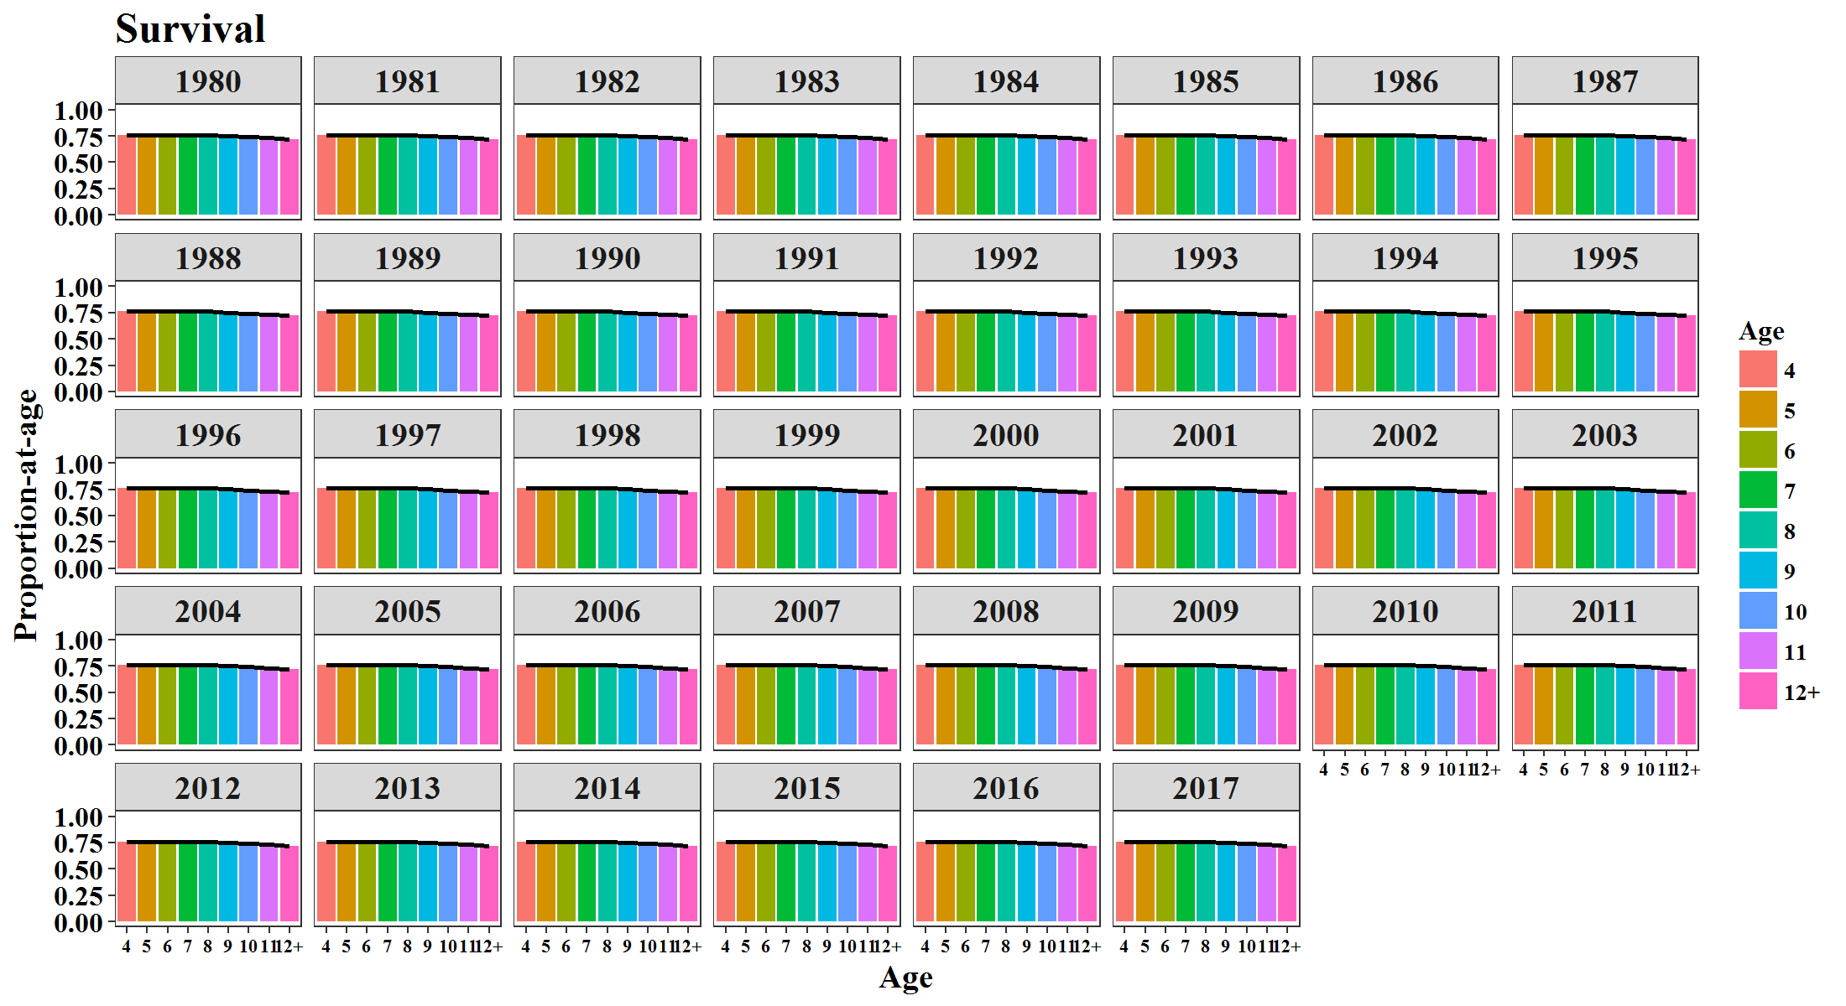

**Figure 9:** Model estimates of survival by year.

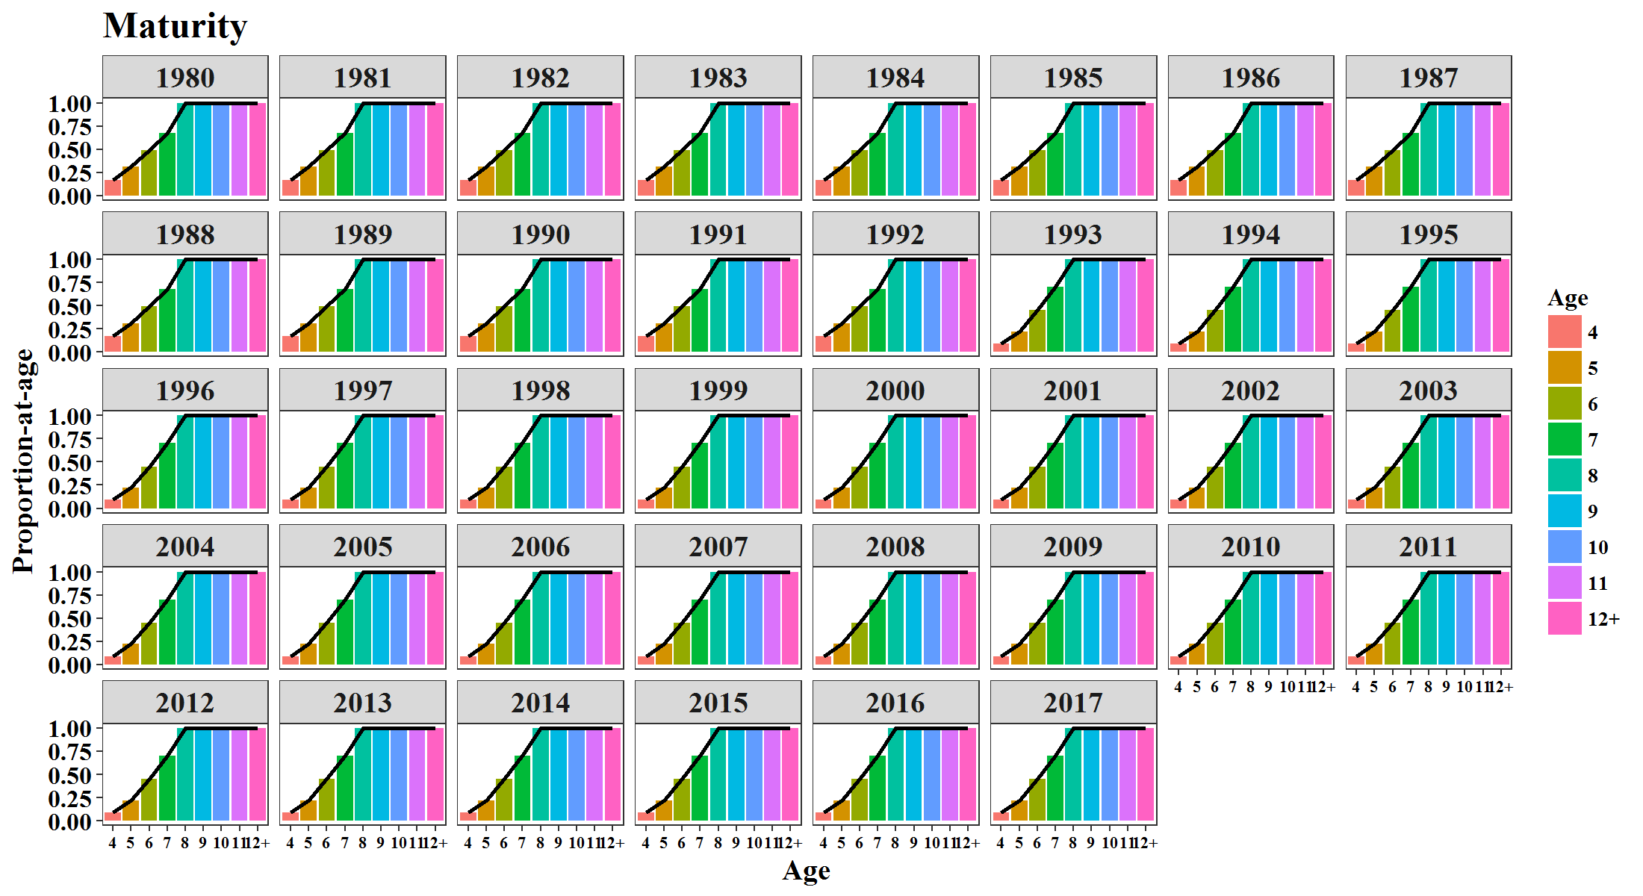

**Figure 10:** Model estimates of maturity at age by year. Estimates for ages 4–7 are estimated with a logistic function; estimates for 8–12+ are fixed at 1.

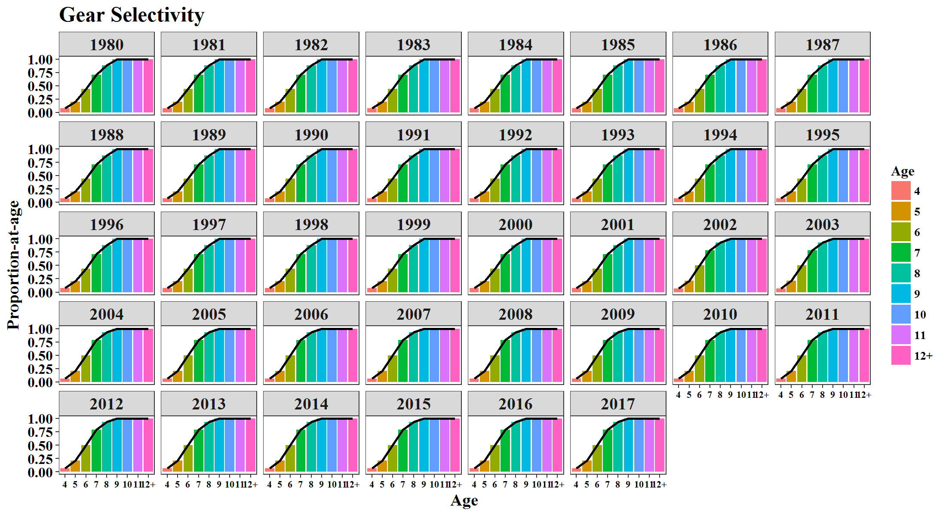 **Figure 11:** Model estimates of purse seine selectivity at age by year. Estimates for ages 4–8 are estimated with a logistic function; estimates for 9–12+ are fixed at 1.

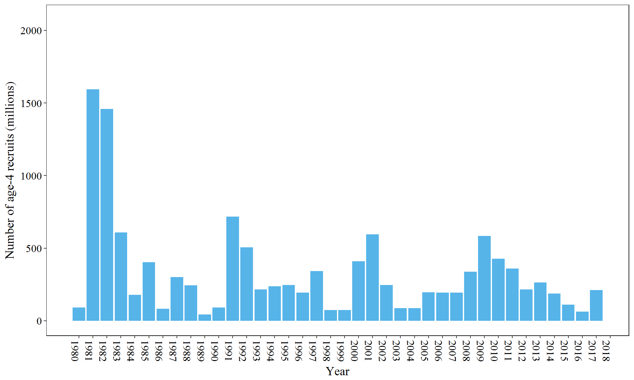

**Figure 12:** Model estimates of age-4 recruit strength (numbers of age-4 mature and immature fish).

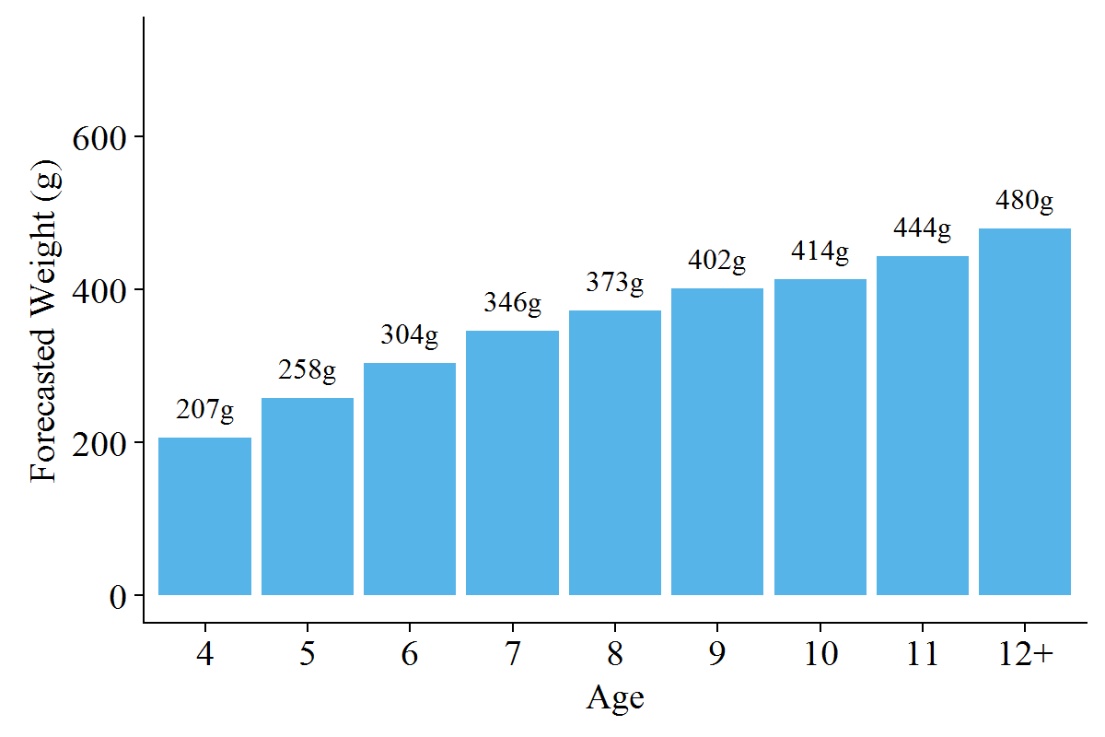

**Figure 13:** Forecasted weight at age (average weight at age from the 2015 and 2017 commercial purse seine sac roe fishery).

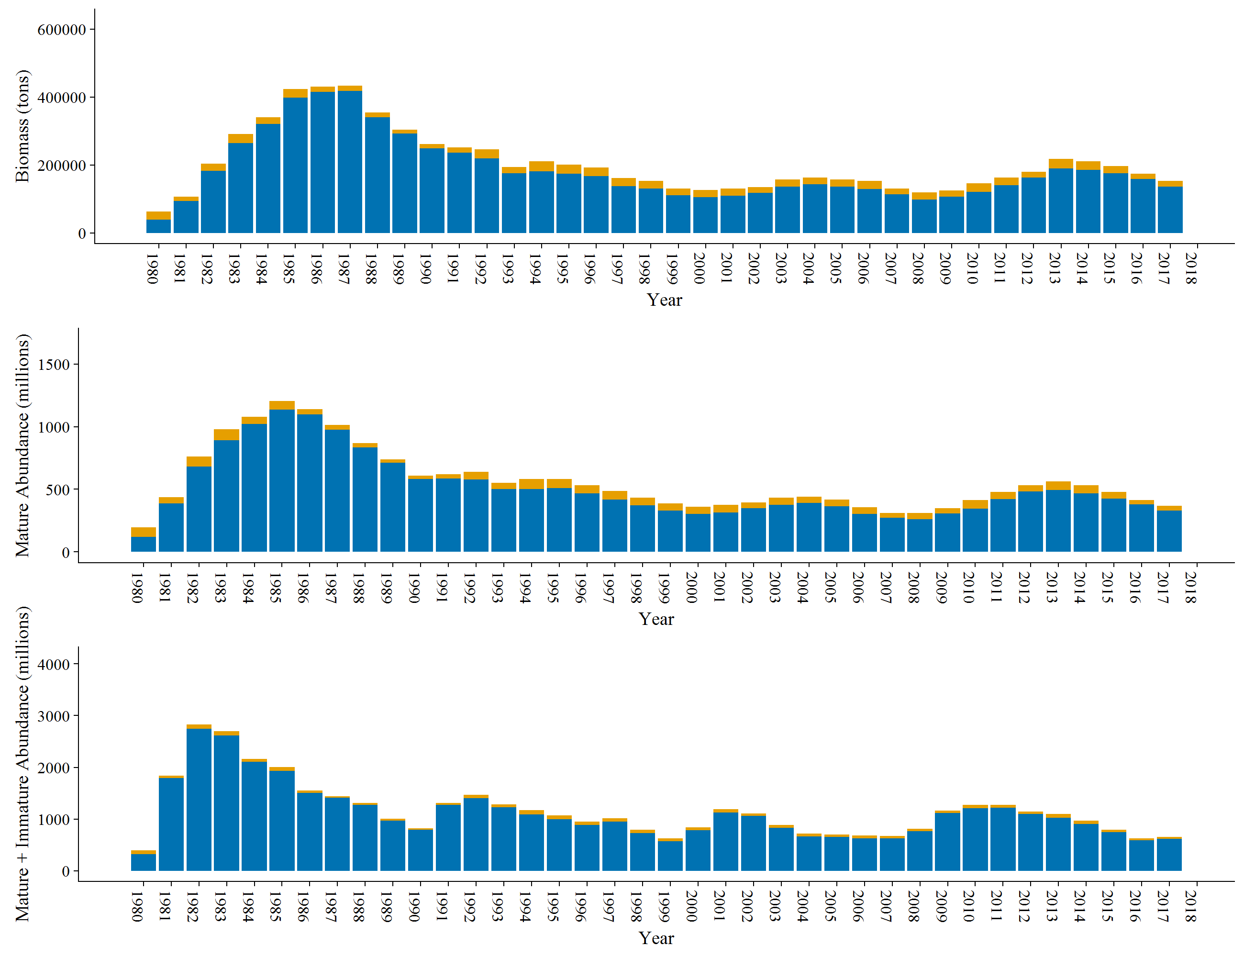 **Figure 14:** Spawning population biomass (blue bars; top figure), spawning population abundance (blue bars; middle figure), immature and spawning abundance (blue bars; bottom figure), and commercial fishery harvest (yellow bars, combined purse seine and gillnet sac roe harvest) over time. The combination of the blue and yellow bars (total height of each bar) is the mature biomass, mature population abundance, or total population abundance.

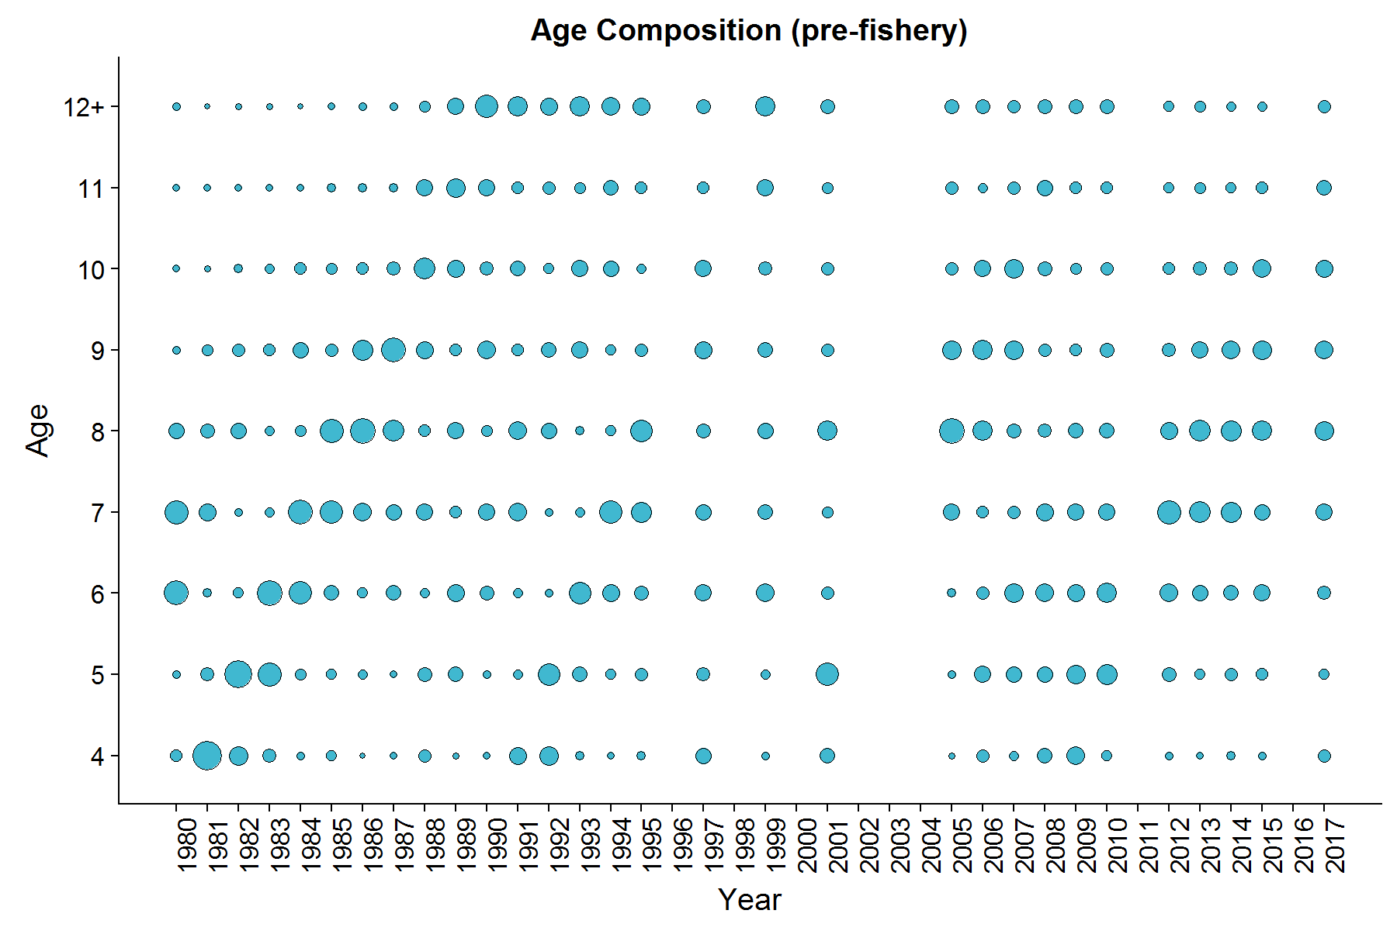**Figure 15:** Togiak herring mature population age composition by year from commercial purse seine samples taken on the days of peak and post-peak aerial surveys. Size of the dots is proportional to percent age composition within a year.

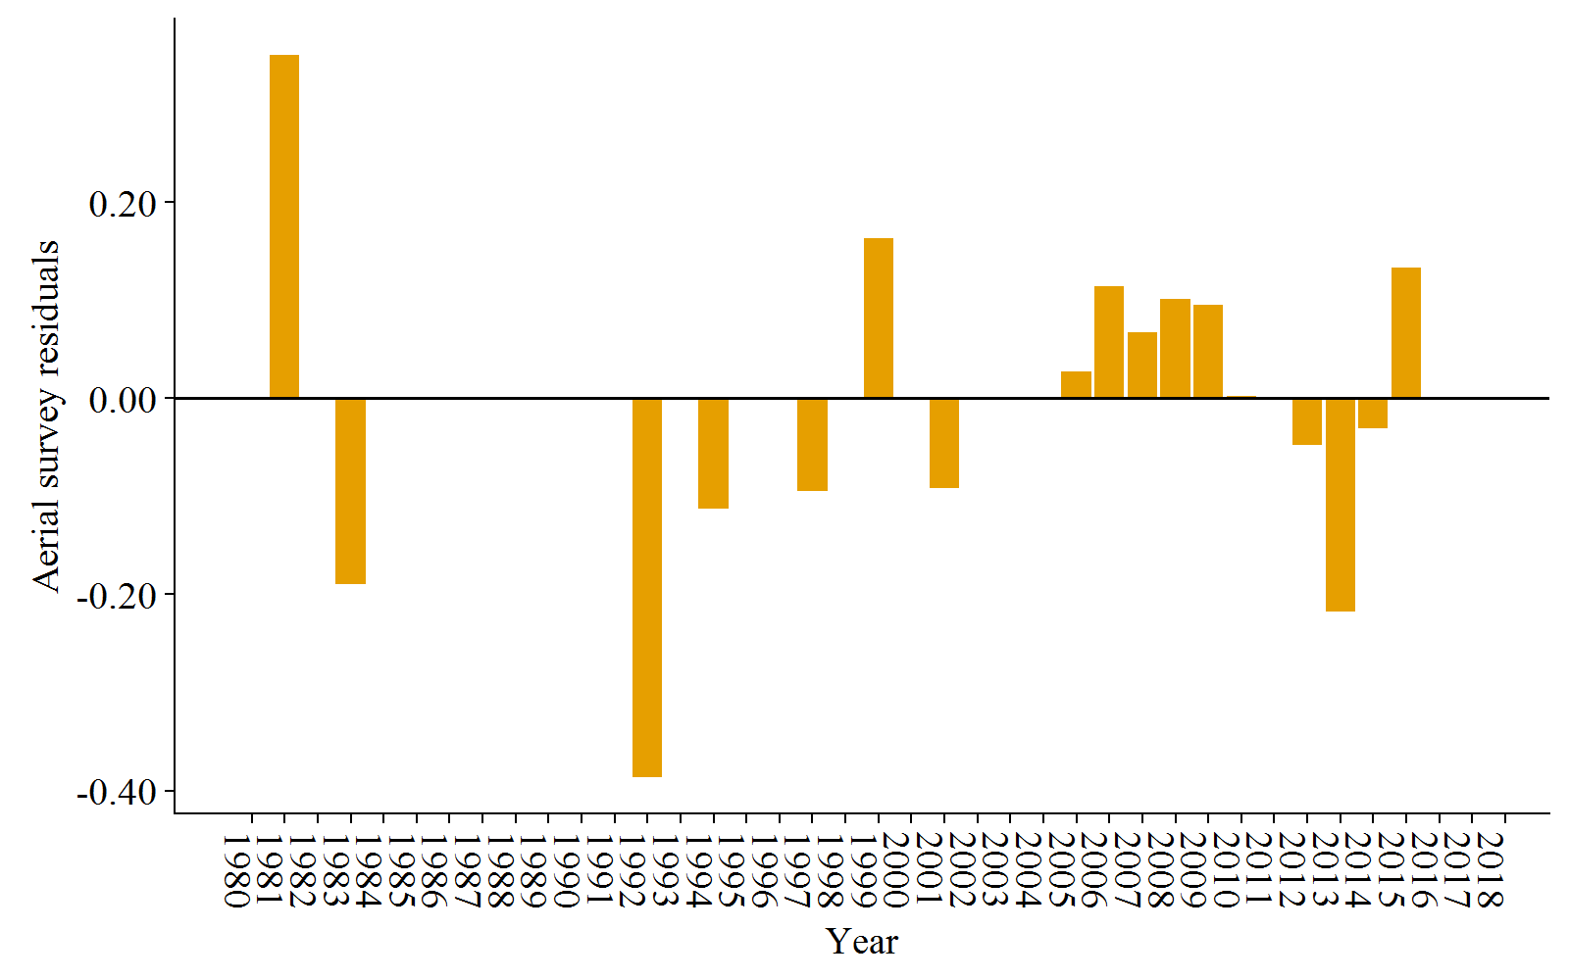**Figure 16:** Residuals from model fits to aerial survey biomass plus pre-peak harvest.

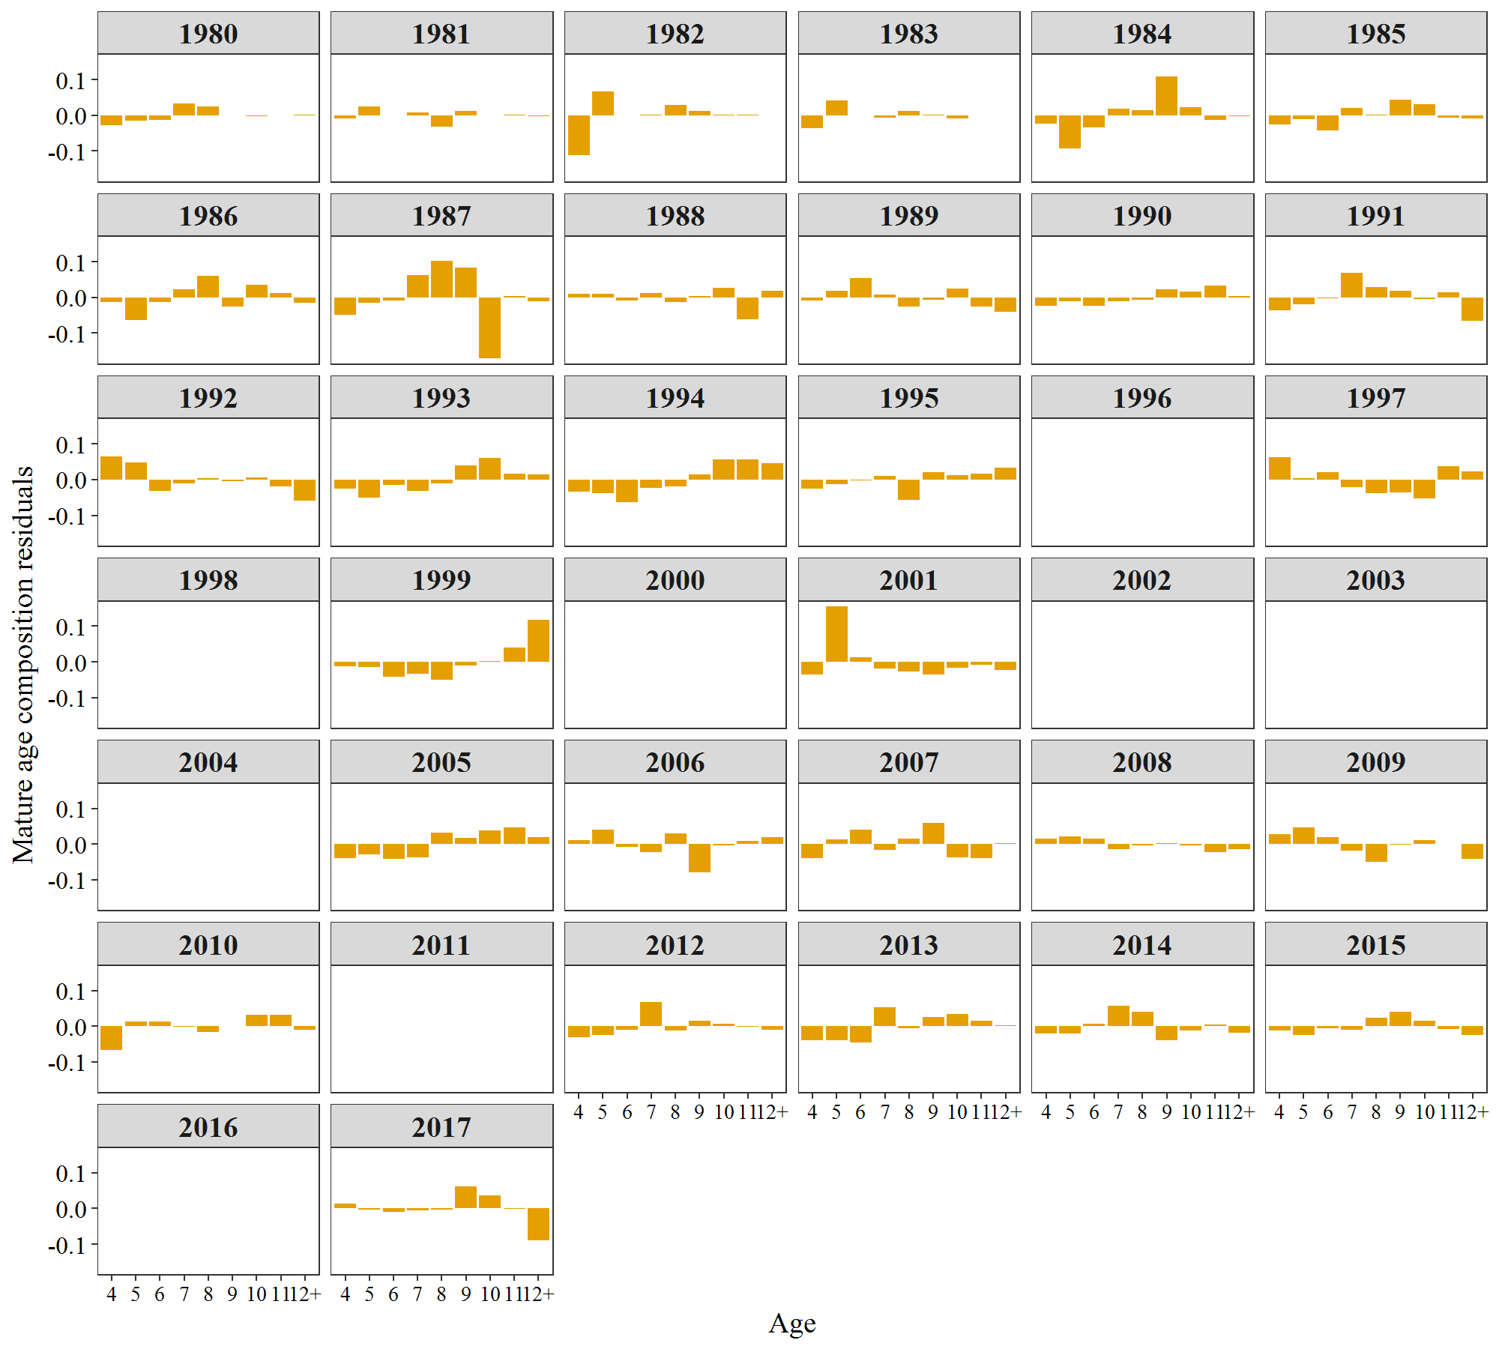

**Figure 17:** Residuals from model fits to age compositions of the mature population.

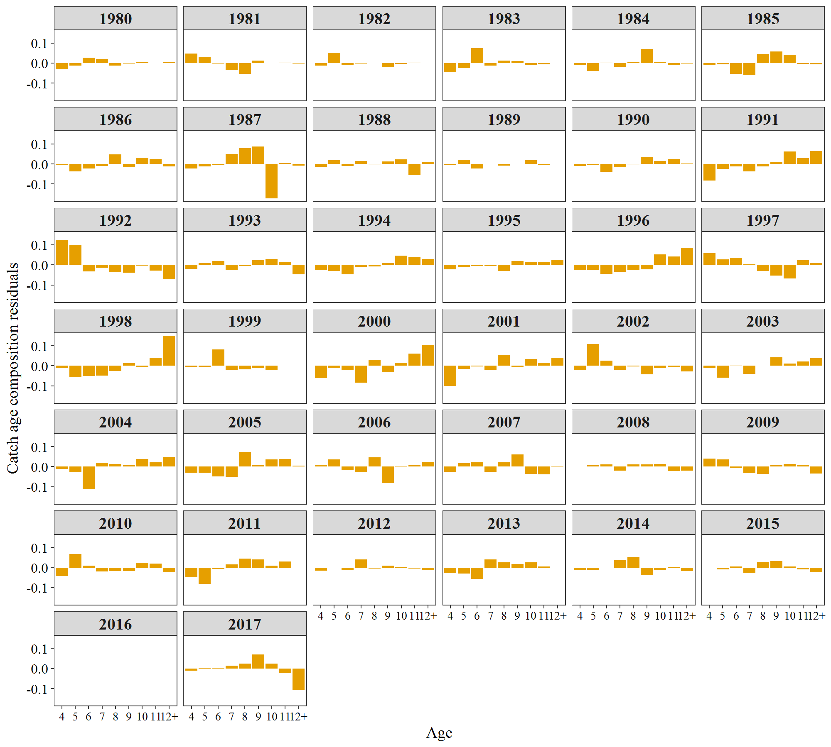

**Figure 18:** Residuals from model fits to commercial purse seine age compositions.

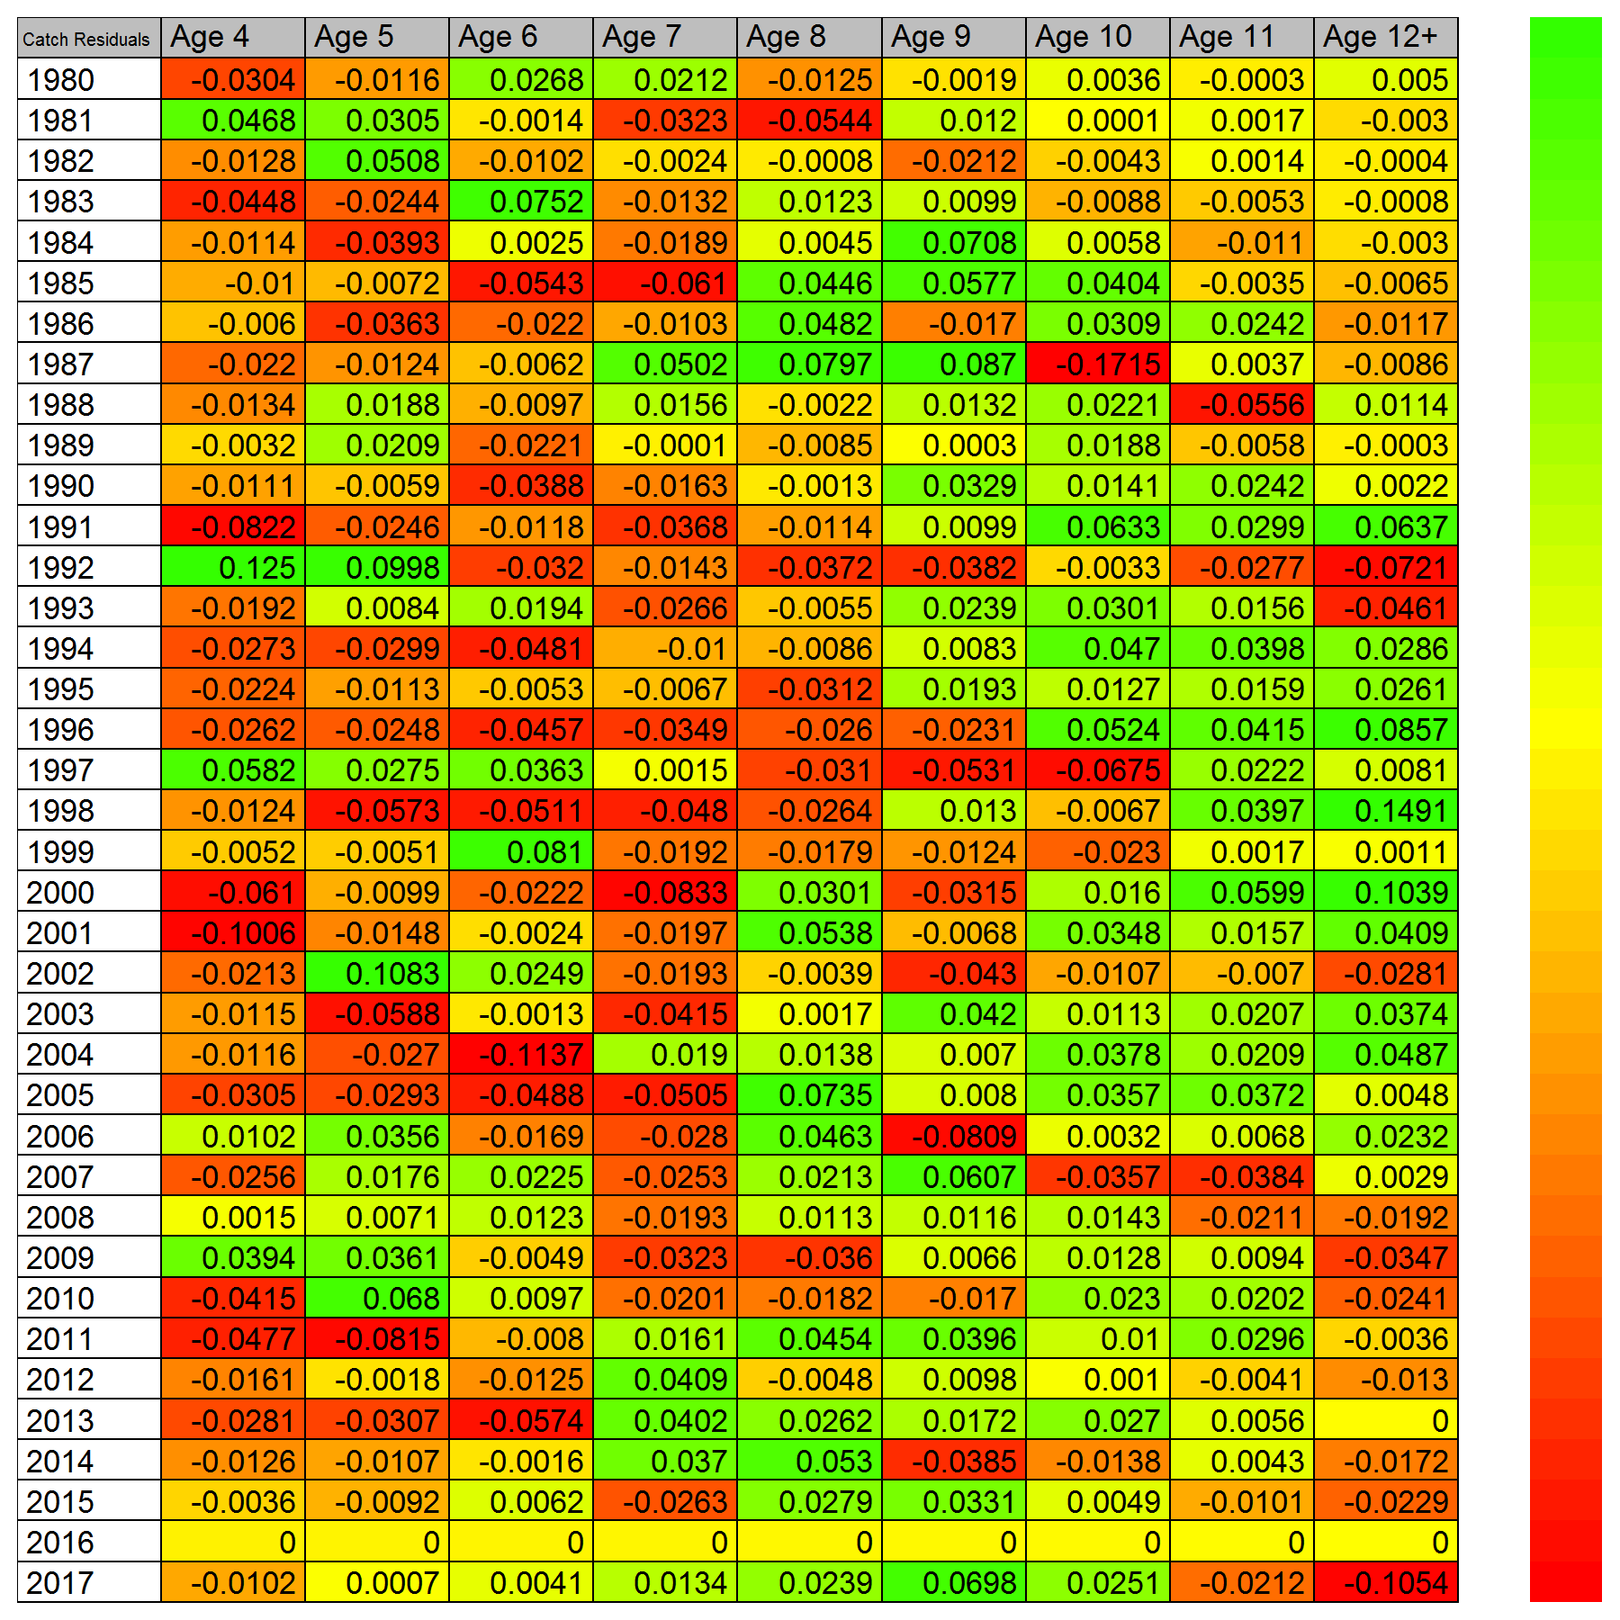

**Figure 19:** Catch-age composition residuals. Positive values suggest that observed data is greater than model-estimated and negative means the opposite.

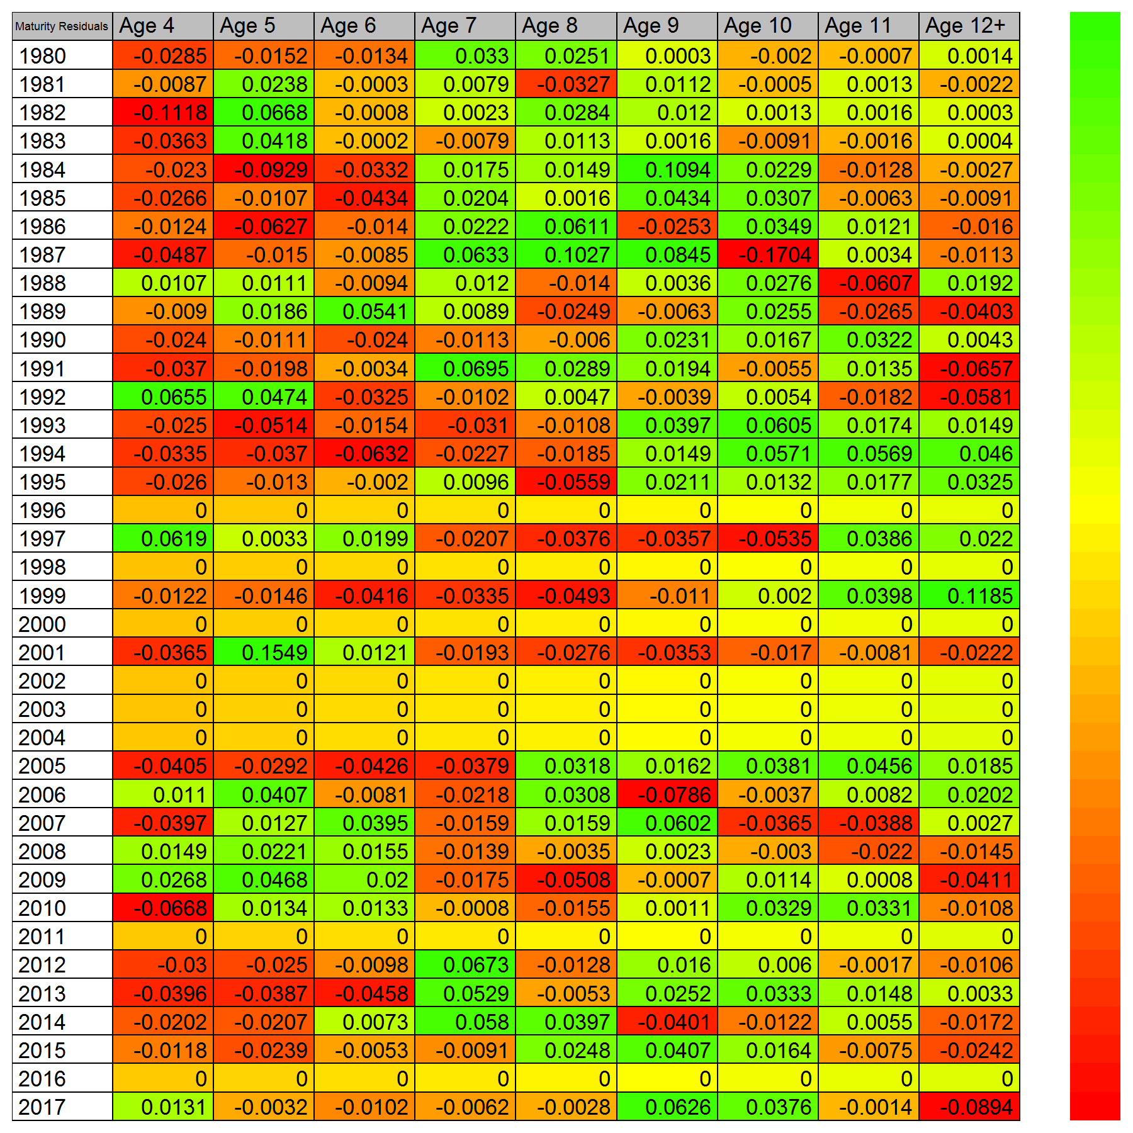

**Figure 20:** Mature population age composition residuals. Positive values suggest that observed data is greater than model-estimated and negative means the opposite.